**Historical reconstruction of the population dynamics of southern right whales in the southwestern Atlantic Ocean**

Romero, M.A., M.A. Coscarella, J.C. Pedraza, R. González and E.A. Crespo

**Supplementary material**

Table S1. Observed abundance and catch series (number of individuals) used in this study. $C_{y}$: annual catch values; $A_{y}$: accumulated number of right whales observed.

|  |  |  |  |  |  |  |  |
| --- | --- | --- | --- | --- | --- | --- | --- |
| Year | $$A_{y}$$ | $$C_{y,min}$$ | $$C_{y,max}$$ | Year | $$A_{y}$$ | $$C_{y,min}$$ | $$C_{y,max}$$ |
| 1678 |  | 20 | 30 | 1849 |  | 2 | 28 |
| 1679 |  | 20 | 30 | 1850 |  | 6 | 34 |
| 1680 |  | 20 | 30 | 1851 |  | 1 | 1 |
| 1681 |  | 20 | 30 | 1852 |  | 1 | 1 |
| 1682 |  | 20 | 30 | 1853 |  | 0 | 2 |
| 1683 |  | 20 | 30 | 1854 |  | 0 | 0 |
| 1684 |  | 20 | 30 | 1855 |  | 0 | 2 |
| 1685 |  | 20 | 30 | 1856 |  | 1 | 44 |
| 1686 |  | 20 | 30 | 1857 |  | 6 | 8 |
| 1687 |  | 20 | 30 | 1858 |  | 7 | 19 |
| 1688 |  | 20 | 30 | 1859 |  | 5 | 6 |
| 1689 |  | 20 | 30 | 1860 |  | 8 | 14 |
| 1690 |  | 20 | 30 | 1861 |  | 0 | 10 |
| 1691 |  | 20 | 30 | 1862 |  | 5 | 16 |
| 1692 |  | 20 | 30 | 1863 |  | 15 | 34 |
| 1693 |  | 20 | 30 | 1864 |  | 7 | 22 |
| 1694 |  | 20 | 30 | 1865 |  | 0 | 23 |
| 1695 |  | 20 | 30 | 1866 |  | 5 | 17 |
| 1696 |  | 20 | 30 | 1867 |  | 0 | 3 |
| 1697 |  | 20 | 30 | 1868 |  | 0 | 24 |
| 1698 |  | 20 | 30 | 1869 |  | 0 | 45 |
| 1699 |  | 20 | 30 | 1870 |  | 0 | 19 |
| 1700 |  | 20 | 30 | 1871 |  | 0 | 16 |
| 1701 |  | 20 | 30 | 1872 |  | 0 | 25 |
| 1702 |  | 20 | 30 | 1873 |  | 0 | 7 |
| 1703 |  | 20 | 30 | 1874 |  | 0 | 27 |
| 1704 |  | 20 | 30 | 1875 |  | 0 | 10 |
| 1705 |  | 20 | 30 | 1876 |  | 0 | 5 |
| 1706 |  | 20 | 30 | 1877 |  | 0 | 4 |
| 1707 |  | 20 | 30 | 1878 |  | 2 | 17 |
| 1708 |  | 20 | 30 | 1879 |  | 5 | 21 |
| 1709 |  | 20 | 30 | 1880 |  | 0 | 27 |
| 1710 |  | 20 | 30 | 1881 |  | 0 | 12 |
| 1711 |  | 20 | 30 | 1882 |  | 0 | 21 |
| 1712 |  | 20 | 30 | 1883 |  | 0 | 36 |
| 1713 |  | 20 | 30 | 1884 |  | 0 | 15 |
| 1714 |  | 20 | 30 | 1885 |  | 0 | 7 |
| 1715 |  | 20 | 30 | 1886 |  | 0 | 12 |
| 1716 |  | 20 | 30 | 1887 |  | 1 | 28 |
| 1717 |  | 20 | 30 | 1888 |  | 4 | 23 |
| 1718 |  | 20 | 30 | 1889 |  | 3 | 40 |
| 1719 |  | 20 | 30 | 1890 |  | 0 | 13 |
| 1720 |  | 20 | 30 | 1891 |  | 0 | 18 |
| 1721 |  | 20 | 30 | 1892 |  | 0 | 2 |
| 1722 |  | 20 | 30 | 1893 |  | 0 | 73 |
| 1723 |  | 20 | 30 | 1894 |  | 0 | 41 |
| 1724 |  | 20 | 30 | 1895 |  | 0 | 8 |
| 1725 |  | 20 | 30 | 1896 |  | 0 | 0 |
| 1726 |  | 20 | 30 | 1897 |  | 0 | 2 |
| 1727 |  | 20 | 30 | 1898 |  | 0 | 0 |
| 1728 |  | 20 | 30 | 1899 |  | 0 | 32 |
| 1729 |  | 20 | 30 | 1900 |  | 0 | 0 |
| 1730 |  | 20 | 30 | 1901 |  | 0 | 0 |
| 1731 |  | 20 | 30 | 1902 |  | 0 | 0 |
| 1732 |  | 20 | 30 | 1903 |  | 0 | 0 |
| 1733 |  | 20 | 30 | 1904 |  | 0 | 0 |
| 1734 |  | 20 | 30 | 1905 |  | 0 | 0 |
| 1735 |  | 20 | 30 | 1906 |  | 0 | 0 |
| 1736 |  | 20 | 30 | 1907 |  | 93 | 93 |
| 1737 |  | 20 | 30 | 1908 |  | 65 | 65 |
| 1738 |  | 20 | 30 | 1909 |  | 56 | 56 |
| 1739 |  | 20 | 30 | 1910 |  | 117 | 117 |
| 1740 |  | 20 | 30 | 1911 |  | 95 | 95 |
| 1741 |  | 20 | 30 | 1912 |  | 26 | 26 |
| 1742 |  | 20 | 30 | 1913 |  | 67 | 67 |
| 1743 |  | 20 | 30 | 1914 |  | 21 | 21 |
| 1744 |  | 20 | 30 | 1915 |  | 19 | 19 |
| 1745 |  | 20 | 30 | 1916 |  | 15 | 15 |
| 1746 |  | 20 | 30 | 1917 |  | 54 | 54 |
| 1747 |  | 20 | 30 | 1918 |  | 14 | 14 |
| 1748 |  | 104 | 196 | 1919 |  | 15 | 15 |
| 1749 |  | 104 | 196 | 1920 |  | 13 | 13 |
| 1750 |  | 104 | 196 | 1921 |  | 10 | 10 |
| 1751 |  | 20 | 30 | 1922 |  | 1 | 1 |
| 1752 |  | 20 | 30 | 1923 |  | 12 | 12 |
| 1753 |  | 20 | 30 | 1924 |  | 12 | 12 |
| 1754 |  | 20 | 30 | 1925 |  | 1 | 1 |
| 1755 |  | 20 | 30 | 1926 |  | 1 | 1 |
| 1756 |  | 20 | 30 | 1927 |  | 3 | 3 |
| 1757 |  | 20 | 30 | 1928 |  | 3 | 3 |
| 1758 |  | 20 | 30 | 1929 |  | 1 | 1 |
| 1759 |  | 20 | 30 | 1930 |  | 1 | 1 |
| 1760 |  | 20 | 30 | 1931 |  | 2 | 2 |
| 1761 |  | 20 | 1750 | 1932 |  | 1 | 1 |
| 1762 |  | 20 | 1750 | 1933 |  | 1 | 1 |
| 1763 |  | 20 | 1750 | 1934 |  | 9 | 9 |
| 1764 |  | 20 | 1750 | 1935 |  | 0 | 0 |
| 1765 |  | 20 | 1750 | 1936 |  | 0 | 0 |
| 1766 |  | 20 | 1750 | 1937 |  | 0 | 0 |
| 1767 |  | 20 | 1750 | 1938 |  | 0 | 0 |
| 1768 |  | 20 | 1750 | 1939 |  | 1 | 1 |
| 1769 |  | 20 | 1750 | 1940 |  | 1 | 1 |
| 1770 |  | 20 | 1750 | 1941 |  | 0 | 0 |
| 1771 |  | 0 | 1750 | 1942 |  | 0 | 0 |
| 1772 |  | 1002 | 1002 | 1943 |  | 0 | 0 |
| 1773 |  | 1003 | 1003 | 1944 |  | 0 | 0 |
| 1774 |  | 1006 | 1006 | 1945 |  | 0 | 0 |
| 1775 |  | 1016 | 1016 | 1946 |  | 1 | 1 |
| 1776 |  | 1326 | 1326 | 1947 |  | 0 | 0 |
| 1777 |  | 994 | 994 | 1948 |  | 0 | 0 |
| 1778 |  | 970 | 970 | 1949 |  | 0 | 0 |
| 1779 |  | 880 | 880 | 1950 |  | 0 | 0 |
| 1780 |  | 772 | 772 | 1951 |  | 0 | 0 |
| 1781 |  | 700 | 700 | 1952 |  | 0 | 0 |
| 1782 |  | 645 | 645 | 1953 |  | 5 | 5 |
| 1783 |  | 635 | 635 | 1954 |  | 0 | 0 |
| 1784 |  | 670 | 670 | 1955 |  | 1 | 1 |
| 1785 |  | 907 | 907 | 1956 |  | 0 | 0 |
| 1786 |  | 857 | 857 | 1957 |  | 10 | 10 |
| 1787 |  | 1175 | 1175 | 1958 |  | 0 | 0 |
| 1788 |  | 1175 | 1175 | 1959 |  | 0 | 0 |
| 1789 |  | 854 | 854 | 1960 |  | 1 | 1 |
| 1790 |  | 720 | 720 | 1961 |  | 1335 | 1335 |
| 1791 |  | 791 | 791 | 1962 |  | 509 | 509 |
| 1792 |  | 780 | 780 | 1963 |  | 37 | 37 |
| 1793 |  | 760 | 760 | 1964 |  | 0 | 0 |
| 1794 |  | 610 | 610 | 1965 |  | 0 | 0 |
| 1795 |  | 780 | 780 | 1966 |  | 47 | 47 |
| 1796 |  | 548 | 548 | 1967 |  | 0 | 0 |
| 1797 |  | 518 | 518 | 1968 |  | 0 | 0 |
| 1798 |  | 396 | 396 | 1969 |  | 0 | 0 |
| 1799 |  | 376 | 376 | 1970 |  | 0 | 0 |
| 1800 |  | 650 | 650 | 1971 |  | 0 | 0 |
| 1801 |  | 673 | 673 | 1972 |  | 0 | 0 |
| 1802 |  | 601 | 601 | 1973 |  | 1 | 1 |
| 1803 |  | 727 | 727 | 1974 |  | 0 | 0 |
| 1804 |  | 581 | 581 | 1975 |  | 0 | 0 |
| 1805 |  | 577 | 577 | 1976 |  | 0 | 0 |
| 1806 |  | 553 | 553 | 1977 |  | 0 | 0 |
| 1807 |  | 474 | 474 | 1978 |  | 0 | 0 |
| 1808 |  | 667 | 667 | 1979 |  | 0 | 0 |
| 1809 |  | 543 | 543 | 1980 |  | 0 | 0 |
| 1810 |  | 400 | 400 | 1981 |  | 0 | 0 |
| 1811 |  | 184 | 184 | 1982 |  | 0 | 0 |
| 1812 |  | 40 | 40 | 1983 |  | 0 | 0 |
| 1813 |  | 34 | 34 | 1984 |  | 0 | 0 |
| 1814 |  | 0 | 673 | 1985 |  | 0 | 0 |
| 1815 |  | 0 | 647 | 1986 |  | 0 | 0 |
| 1816 |  | 0 | 1027 | 1987 |  | 0 | 0 |
| 1817 |  | 71 | 918 | 1988 |  | 0 | 0 |
| 1818 |  | 113 | 1154 | 1989 |  | 0 | 0 |
| 1819 |  | 201 | 1436 | 1990 |  | 0 | 0 |
| 1820 |  | 233 | 1454 | 1991 |  | 0 | 0 |
| 1821 |  | 171 | 1216 | 1992 |  | 0 | 0 |
| 1822 |  | 133 | 774 | 1993 |  | 0 | 0 |
| 1823 |  | 148 | 864 | 1994 |  | 0 | 0 |
| 1824 |  | 136 | 835 | 1995 |  | 0 | 0 |
| 1825 |  | 244 | 762 | 1996 |  | 0 | 0 |
| 1826 |  | 163 | 754 | 1997 |  | 0 | 0 |
| 1827 |  | 173 | 805 | 1998 |  | 0 | 0 |
| 1828 |  | 122 | 788 | 1999 | 956 | 0 | 0 |
| 1829 |  | 172 | 663 | 2000 | 1,868 | 0 | 0 |
| 1830 |  | 187 | 854 | 2001 |  | 0 | 0 |
| 1831 |  | 195 | 274 | 2002 |  | 0 | 0 |
| 1832 |  | 203 | 233 | 2003 |  | 0 | 0 |
| 1833 |  | 229 | 309 | 2004 |  | 0 | 0 |
| 1834 |  | 199 | 243 | 2005 | 1,193 | 0 | 0 |
| 1835 |  | 78 | 443 | 2006 | 1,473 | 0 | 0 |
| 1836 |  | 107 | 232 | 2007 | 2,237 | 0 | 0 |
| 1837 |  | 13 | 378 | 2008 | 1,953 | 0 | 0 |
| 1838 |  | 21 | 258 | 2009 | 1,499 | 0 | 0 |
| 1839 |  | 1 | 60 | 2010 | 1,676 | 0 | 0 |
| 1840 |  | 2 | 146 | 2011 | 1,387 | 0 | 0 |
| 1841 |  | 2 | 83 | 2012 | 1,936 | 0 | 0 |
| 1842 |  | 0 | 29 | 2013 | 2,238 | 0 | 0 |
| 1843 |  | 2 | 21 | 2014 | 1,592 | 0 | 0 |
| 1844 |  | 1 | 1 | 2015 | 1,234 | 0 | 0 |
| 1845 |  | 4 | 79 | 2016 | 954 | 0 | 0 |
| 1846 |  | 3 | 6 | 2017 | 1,570 | 0 | 0 |
| 1847 |  | 0 | 67 | 2018 | 2,201 | 0 | 0 |
| 1848 |  | 5 | 45 | 2019 | 1,291 | 0 | 0 |

Figure S1. Posterior probability (thick line) and post-model pre-data (thin line) distributions of the key biological parameters for the base case and sensitivity scenarios of the assessment of southern right whale (SRW) *Eubalaena australis*. The posterior probability distribution of the base case is illustrated in the thick dotted line.

S1.1 Base Case

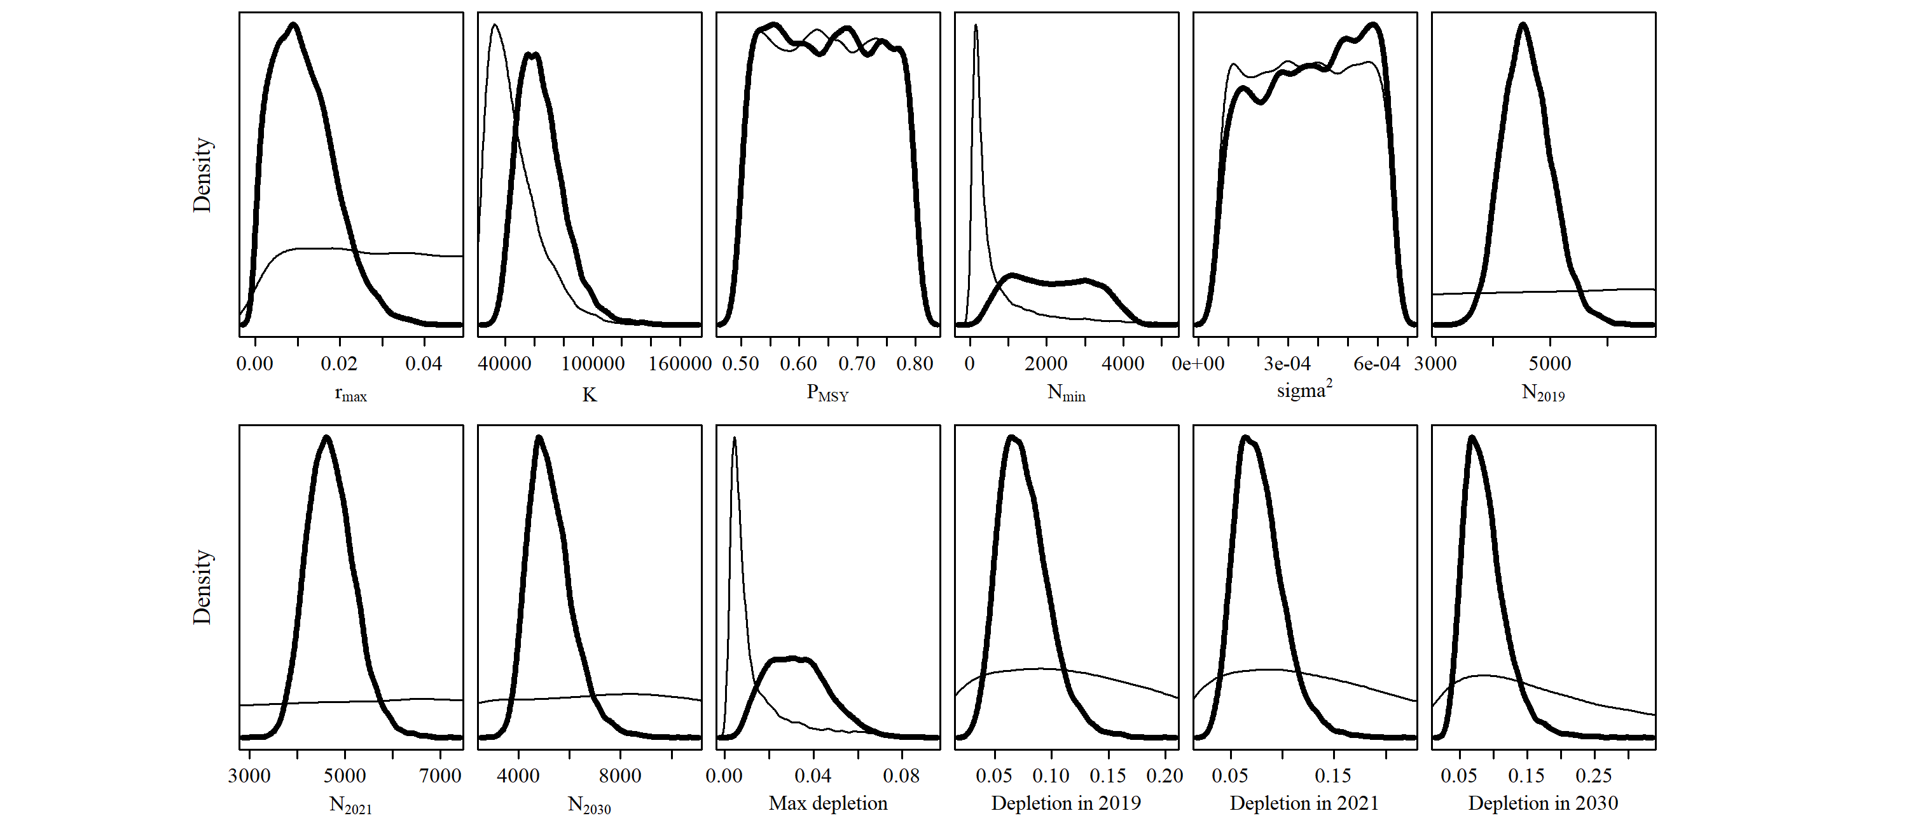

S1.2 Scen 1

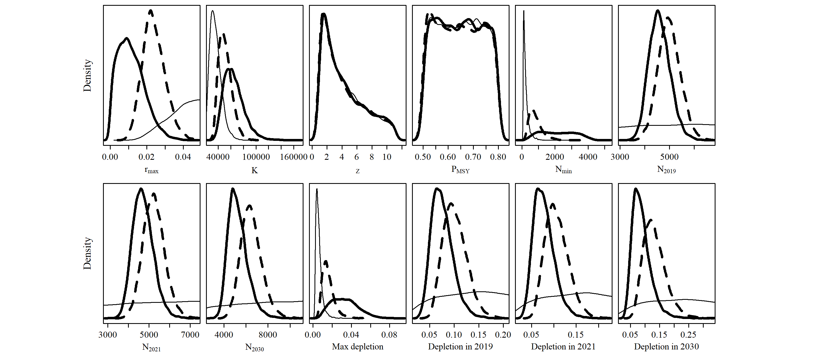

S1.3 Scen 2

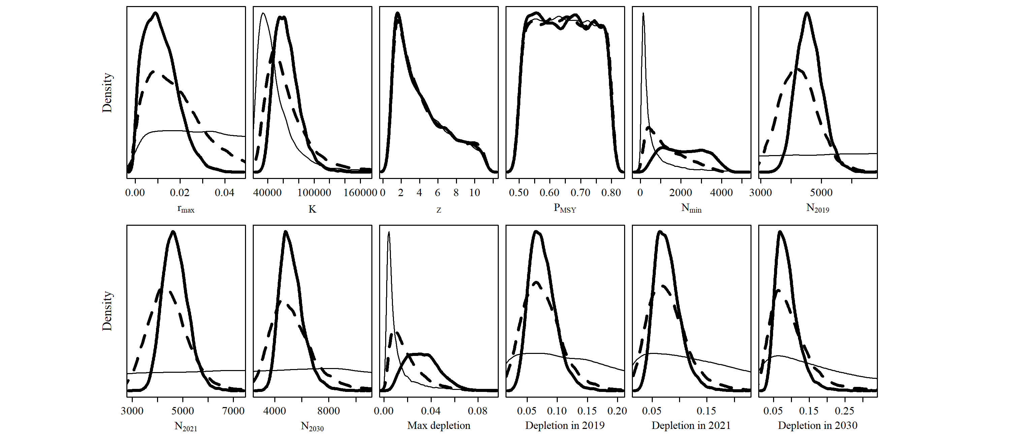

S1.4 Scen 3

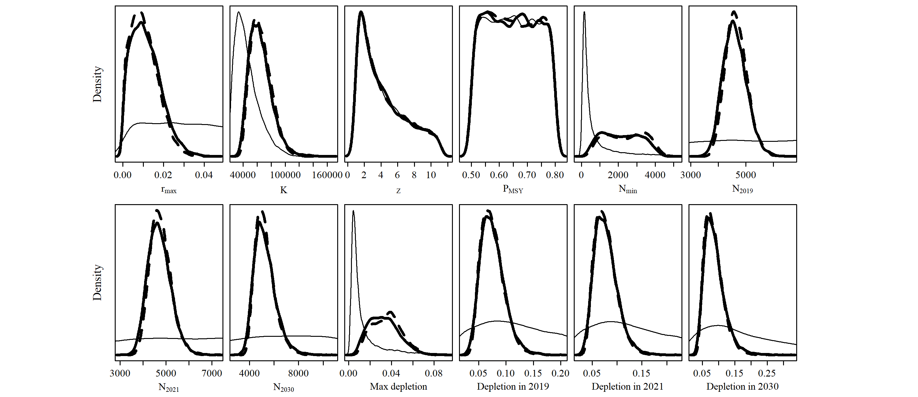

S1.5 Scen 4

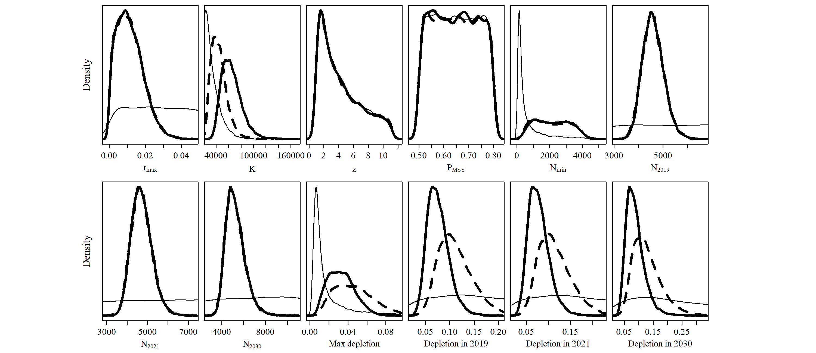

S1.6 Scen 5

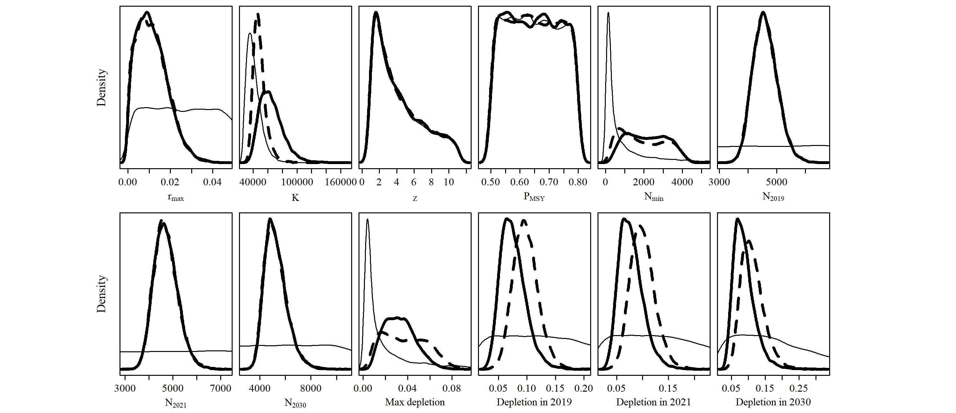

S1.7 Scen 6

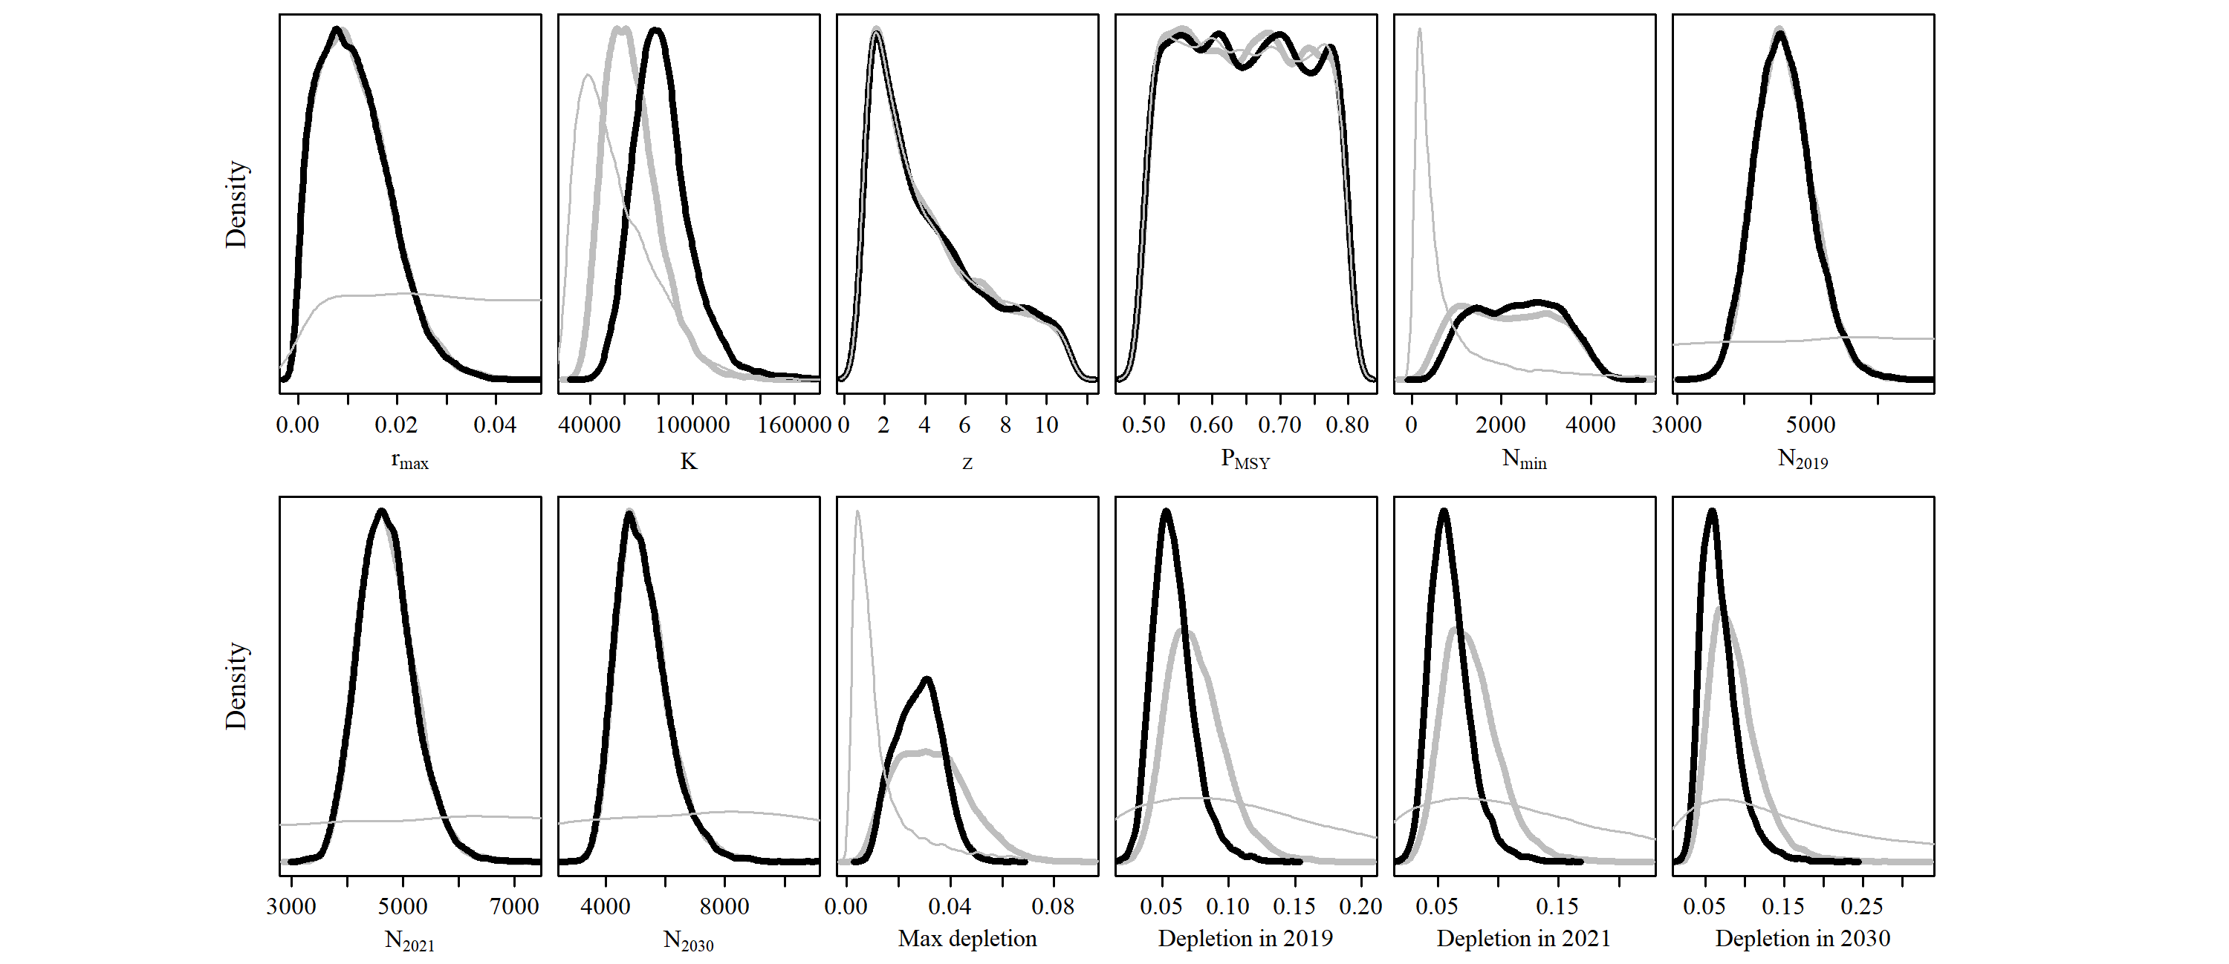

S1.8 Scen 7

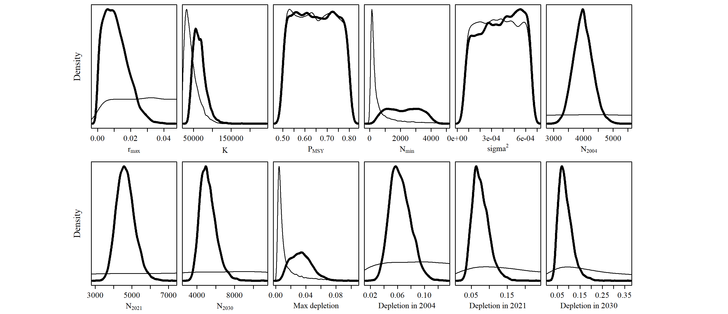

S1.9 Scen 8

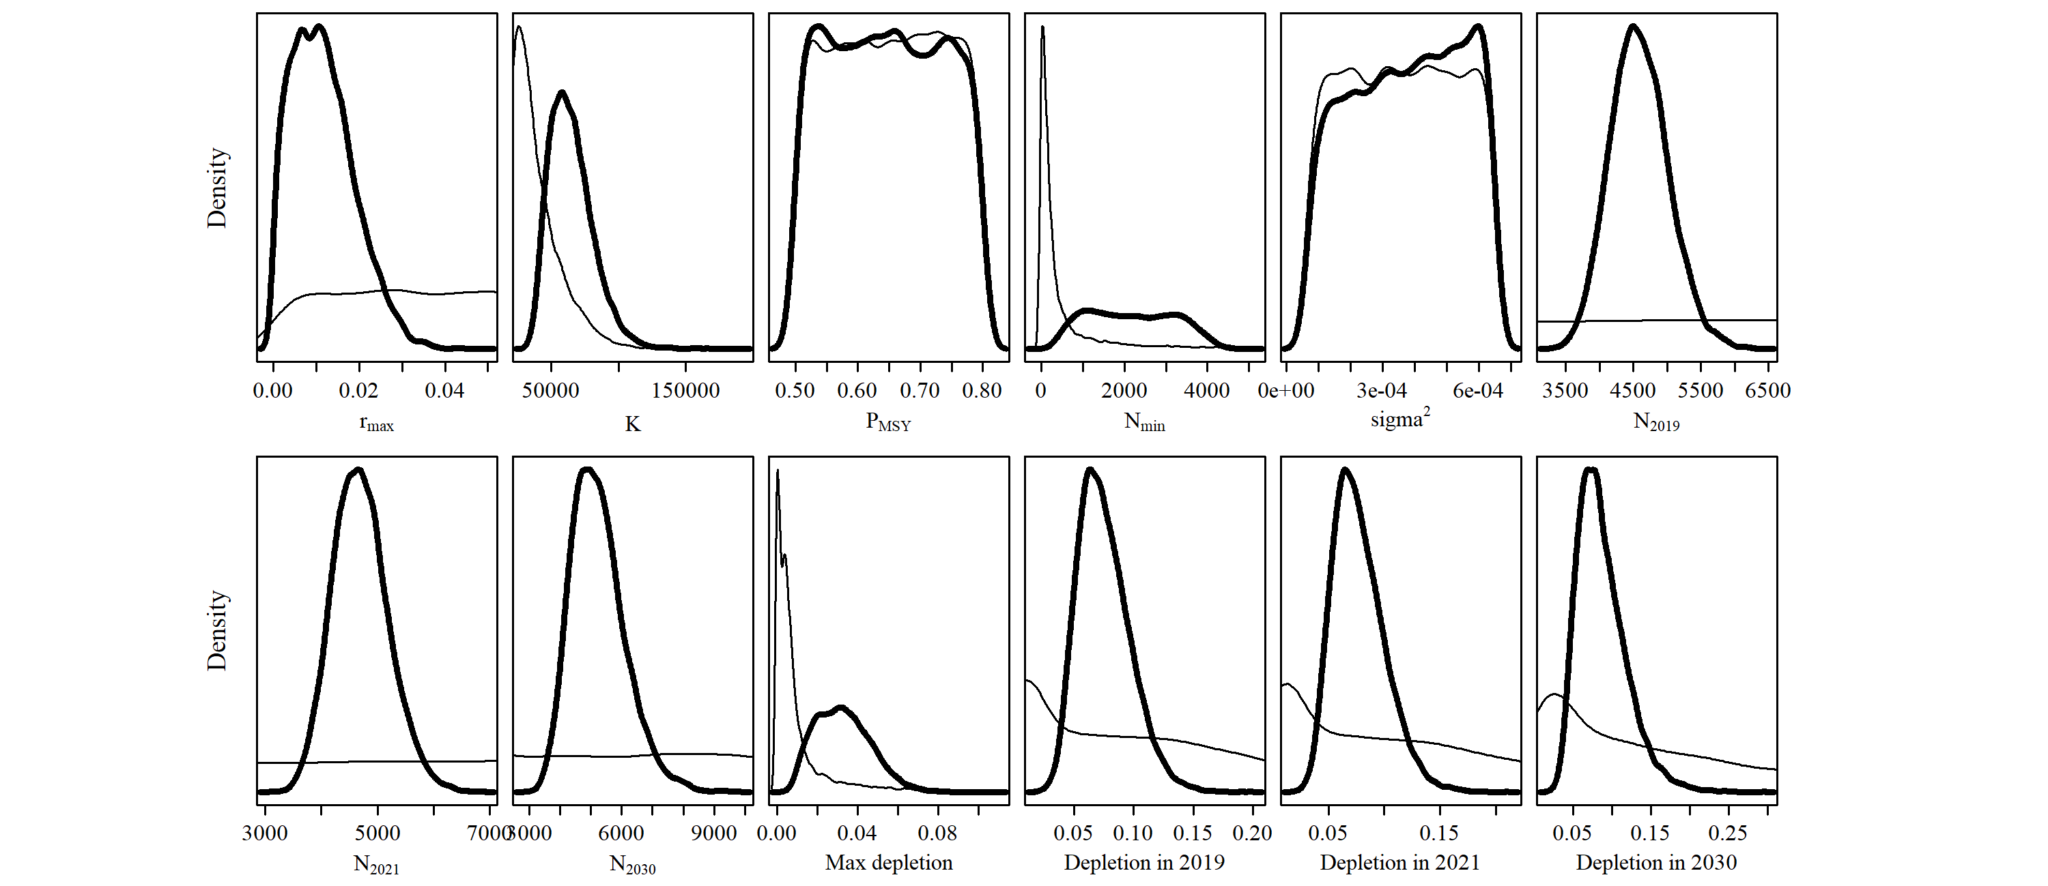

S1.10 Scen 9

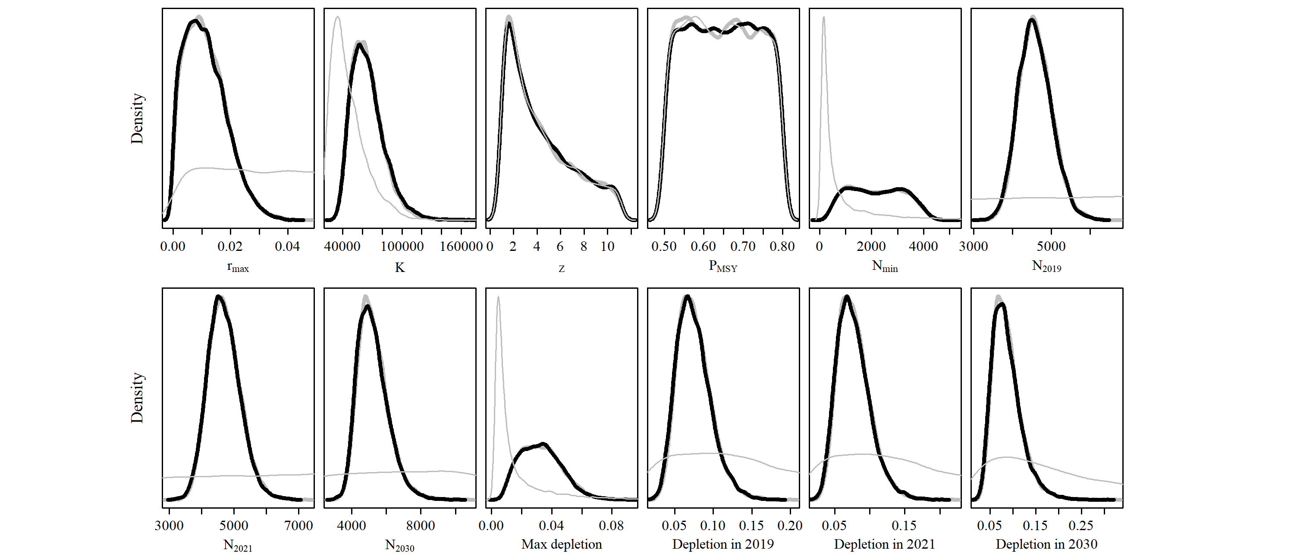

S1.11 Scen 10

